Charles Richard Ault
March 4, 1934 – June 2, 1997

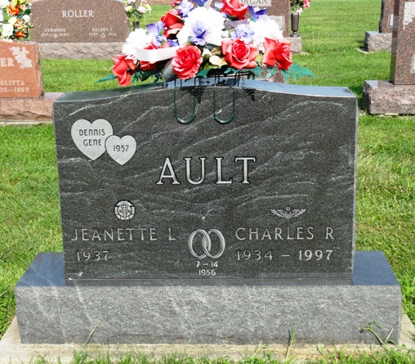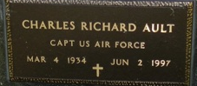
Photos by Kay Bradtmiller

Charles R. Ault, 63

Charles R. “Smokey” Ault, 63, of Ossian died at 12:40 a.m. Monday at Lutheran Hospital in Fort Wayne. He was a mechanic at B.F. Goodrich, retiring in 1994 after 30 years. Mr. Ault served from 1954 -1964 with the U. S. Air Force.
He was born at Ossian on March 4, 1934 to Harvey A. and Mary L. Myers Ault. His mother survives and resides in Ossian. Mr. Ault was married in Fort Wayne on July 14, 1956 to Jeanette L. Kline, who survives.
Also surviving are a daughter, Mrs. Monty (Anita) Smart of Huntington; two sons, Thomas Ault of Markle and David Ault of Honolulu, Hawaii; a brother Gene Ault of Fort Wayne; and five grandchildren.
Services, scheduled for 10 a.m. Thursday, will be at Elzey & Haggard Funeral home in Ossian with Rev. Nigel Everett officiating. Burial will be in Oak Lawn Cemetery at Ossian. Graveside rites will be performed by Bluffton American Legion Post 111. Visiting hours at the funeral home will be from 2 to 4 and 6 to 8 p.m. Wednesday. Memorials to the donor’s choice.

Bluffton News Banner, Wells County, Indian
Tuesday, June 3, 1997, p. 3, c. 1

