Charles E. Ault
June 12, 1880 – March 25, 1912

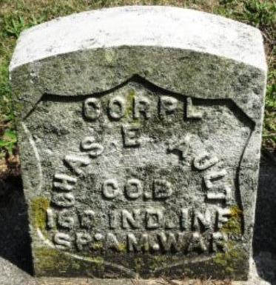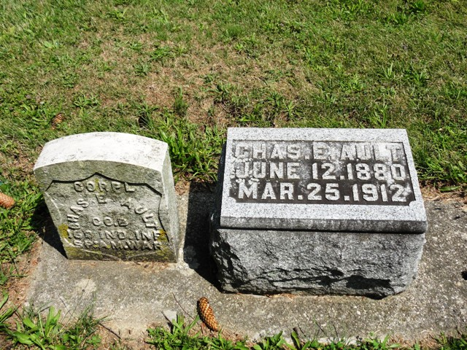
Photos by Kay Bradtmiller

CHARLES AULT BURIED AT OSSIAN
Passed away at home in Fort Wayne from pneumonia
Death recalls accidents

Charles Ault, who for some time was employed by the Pennsylvania Railroad company, died Monday morning at his home at Fort Wayne, after an illness of five months from complication, which followed an attack of pneumonia.
While residing at Decatur Mr. Ault was married to Miss Christena Elzey, eleven years ago, who survives with four children, the oldest being ten years of age. They are: Fred, Harvey, Alice and Arvilla. The deceased was the son of Mr. and Mrs. William Ault. The father died three years ago in Fort Wayne, being killed by a railroad train when returning from church. His mother, who was along, was also struck and injured so that it was necessary to amputate one leg. John Ault, a brother of the deceased, was killed about twelve years ago by a Clover Leaf train east of Decatur, while he was engaged as night watchman at the bridge. One brother, Burt Ault, survives. The funeral was held this morning at 10 o’clock at the home with burial at Ossian.
Mr. Ault was a member of the Ben Hur lodge of Decatur.
Mr. Ault and wife were related to the Elzey families residing in and near Ossian. Readers will remember that Mr. Ault’s mother won a heavy judgment in court here following her injuries in the accident at Fort Wayne and the case is now in the supreme court.

Evening News, Wells County, Indiana
Wednesday, March 27, 1912, p. 2, c. 6

