Charles Frederick Ault
December 27, 1902 – June 21, 1990

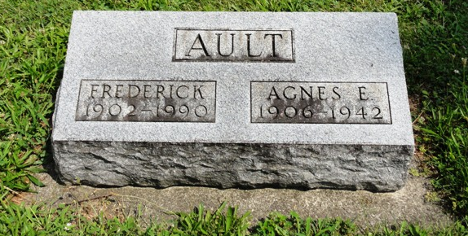
Photo by Kay Bradtmiller

C. Fred Ault, 87, Dies; Former Morris Co. Officer, Director

Chares Fred Ault, 87, retired official for the former John A. Morris Co. wholesale firm in Bluffton, died at 7 a.m. today at his home at 5030S-500E, Bluffton. Death was attributed to complications arising from a stroke three years ago.
Mr. Ault retired in 1967 from the Morris wholesale firm, ending a 45-year career with the company. He was vice president in charge of sales and a member of the board of directors at that time. He had joined the company in 19ss after graduation from Bluffton High School. He became manager of wholesale operation in the early 1930s and, in 1957, when the Morris business was purchased by the G. C. Murphy Co., he became head of sales. He was a member of a group of businessman which purchased the wholesale outlet in 1961.
He had been a resident several years at Lake George after his retirement. Mr. Ault was active in Kiwanis Club and Masonic Lodge organizations. He was a 60-year member of Kiwanis International, serving for 25 years as a club secretary and one year, in 1954, as secretary of the state organization. He was past president of the Bluffton club.
<snip>
A member of the First United Church of Christ, he was born in Fort Wayne Dec. 27, 1902, a son of Charles E & Christina Elzey Ault. A first marriage was to Agnes Evelyn Myers, who died April 29, 1941, and a second marriage on Oct. 24, 1943 was to Ethelbelle Myers, who died Dec. 3, 1984.
Surviving are the one son, Charles Ault of Bluffton; one sister, mrs. Alice Fetters of Colona, Mich.; two half-brothers, Joe Parker of Fort Wayne and James Parker of Bluffton; five grandchildren and nine great-grandchildren.
Services will be at 10 a.m. Saturday at Goodwin Memorial Chapel, where calling will begin at 1 p.m. Friday. Rev. Calvin M. Ley will officiate at the rites and burial will be in Oak Lawn Cemetery at Ossian.
Masonic rites will be performed at 7 p.m. Friday and Kiwanis services at 7:15 p.m. Friday at the funeral home.
Preferred memorials are gifts to the Kiwanis Club of Bluffton or Home Health Care Services

Bluffton News Banner, Wells County, Indian
Thursday, June 21, 1990, p. 3, c. 1

