Fleetwood “Wood” Archbold
January 19, 1872 – December 6, 1950

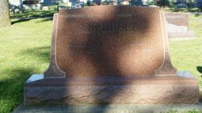
Photo by HoosierGirl88

Indiana, U.S., Death Certificates, 1899-2017
Name Wood Archbold
Gender Male
Race White
Marital Status Widowed
Age 78
Birth Date 19 Jan 1872
Birth Place Wells County, Indiana
Death Date 6 Dec 1950
Death Place Bluffton, Wells, Indiana, USA
Death Registration Date 1950
Father Robert Archbold
Mother Druzilla Metz
Informant Thomas Archbold
Burial 12/9/1950 Oak Lawn Cemetery

**
Indiana, Marriages, 1810-2001
Name Wood Archbold
Gender Male
Race White
Age 73
Event Type Marriage Registration (Marriage)
Birth Date 15 Jun 1875
Birth Place Wells, Indiana
Marriage Date 30 Jul 1948
Marriage Place Indiana, United States
Residence Place Bluffton, Indiana
Father Robert Archbold
Mother Druzella Mets Archbold
Spouse Sadie L Watrous
Page 45

