Wilma J. (Carnes) Archbold
December 3, 1917 – October 7, 1988

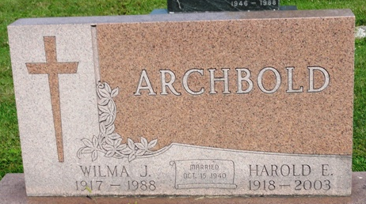
Photo by Kay Bradtmiller

Wilma J. Archbold, 70, died Friday afternoon at Lutheran Hospital. Born in Wells County, she lived in Allen County most of her life. She retired from the Ossian Post Office in 1984 after 10 years.
Surviving are her husband, Harold E.; two sons, Dean L. of Markle and Lyle G. of Ridgetown, Ontario; a daughter, Marilyn Lindquist of Farmington, Conn.; a brother, Robert Carnes, of Fort Wayne; three sisters, Adahleen Lewis of Ossian, Wanda Bainbridge of Fort Wayne, and Phyllis Hardy of Rathdrum, Idaho; and six grandchildren.
Services at 11 a.m. Tuesday in Ossian Nazarene Church. Calling from 2 to 5 and 7 to 9 p.m. today and 2 to 5 and 7 to 9 p.m. Monday in Elzey-Dickey-Haggard Funeral Home, and an hour before services at the church. Memorials to the church building fund.

Journal Gazette, Allen County, Indiana
October 9, 1986, page 15A

