William George Archbold
July 6, 1840 – March 26, 1913

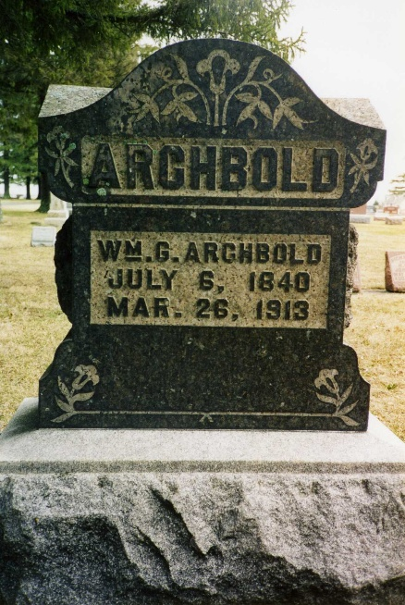
Photo by drbuck

FUNERAL WAS DELAYED
On account of the floods, the funeral of William Archbold, who died at Ossian last Wednesday, was not held until Sunday, in the hopes that the high waters would have subsided until them to allow more of the relatives to attend. Several from this city and vicinity attended, the deceased being a brother of Mrs. William Murphy of this city, of Ezra Archbold of Fort Wayne, and of the late James Archbold of east of the city. He was also an uncle of the Jason Archbold family.
Mr. Archbold was about seventy years of age and had been ailing a year from a complication of diseases. He was at one time a resident of Adams county. He leaves the following children: Mrs. Mart Henline, with whom he lived at Ossian; Burt and James of Ossian, Elizabeth Ormsby, Michigan City.
Decatur Daily Democrat; Adams County, Indiana
Monday, March 31, 1913

**
ARCHBOLD FUNERAL
The funeral of William Archbold, one of the most highly respected citizens of Ossian was held at Ossian Sunday afternoon at 2 o'clock, with burial in the Oaklawn cemetery at that place. Mr. Archbold, who had been suffering severely for the past ten days from leakage of the heart, passed away at the home of his daughter, Mrs. Martin Henline. His sufferings had been so severe for several days that he was not able to lie down.

Bluffton Chronicle, Wells County, Indiana
Wed., April 2, 1913

**
William G. Archbold

Among the prominent farmers of Jefferson township, Wells county, Indiana, is William G. Archbold, who was born in Tuscarawas county, Ohio, July 6, 1839, and is a son of John and Elizabeth (Gibson) Archbold, who came respectively from Ohio and Pennsylvania families. They were married in Tuscarawas county, coming subsequently to Indiana and locating in Adams county, where John Archbold purchased two hundred and five acres of wild land, which he partially cleared and to a great extent improved, but late removed to Decatur, Indiana, where they passed the remainder of their days.
William G. Archbold was reared on the farm on which his parents settled and was well trained in the details of agriculture, though his opportunities for a scholastic training were somewhat meager. Nevertheless he acquired a sufficient knowledge of books to qualify him for a good position in society and for the understanding of everything that books could impart touching his calling and the current events of the day as recorded by the press.
Mr. Archbold was first married, in 1863, to Miss Elmira Ruby, a native of Ohio, but who was early brought to Indiana by her parents. To this union were born two children, namely: James W., who married Minnie Mills, and lives in Union township, and Mary E., now the wife of A. E. Ormsby, of Union township, and has four children living, Ralph, Argus, Brice and Dale.
The second marriage of Mr. Archbold was with Mary C. Sommers, born in Adams county, May 9, 1843, who has borne him three children, viz: David A., who is Married to Grace Deam, daughter of John C. and Amanda (Beadsley) Deam, and has one son Lawrence, who assists his father in operating the farm; Sylvester, who died in infancy and Ioda, who is still with her parents. The parents of Mrs. Mary C. (Sommers) Archbold removed from Adams county to Allen county, Indiana, whence they came to Wells county, and here the father died at Ossian in 1898, his death being greatly deplored by all who knew him.
Mr. Archbold in his political affiliations is a Democrat, but he has never been a strong partisan, much less an office seeker. He started in life poor, and has made all he has by indomitable persistence and skill. His farm is one of the best of its size in Jefferson township and everything about it denotes thrift, enterprise and good management. All or nearly all the improvements on the place have been made by himself, and all are of the most modern and substantial character. He is widely and favorably known throughout his township and is recognized as a public-spirited and liberal-hearted gentleman, ready at all times to promote every project designed for the good of the public. He is one of the best of neighbors, his name being synonymous with truth, fidelity and charity.

Biographical Memoirs of Wells County, Indiana; B. F. Bowen Publisher, Logansport, IN; pg. 491

