Wendell W. “Pete”Archbold
October 8, 1912 – April 10, 1988

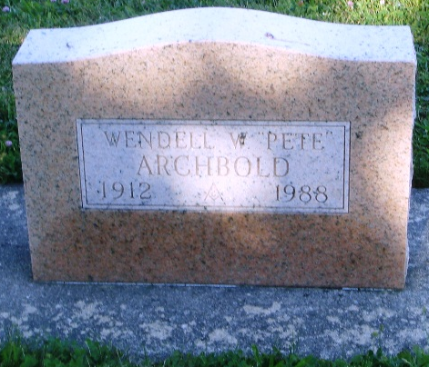
Photo by HoosierGirl88

Indiana, U.S., Death Certificates, 1899-2017
Name Wendell W Archbold
Gender Male
Race White
Marital Status Married
Age 75
Birth Date 12 Oct 1912
Birth Place Wells, Indiana
Death Date 10 Apr 1988
Death Place Ossian, Wells, Indiana, USA
Death Registration Date 1988
Father Curtis Archbold
Mother Iva Hoppingardner
Spouse Mabel M (Wilson) Archbold, informant
Burial 4/13/1988 Oak Lawn Cemetery

