Vera M. (Christlieb) Archbold
October 18, 1925 – December 10, 2013

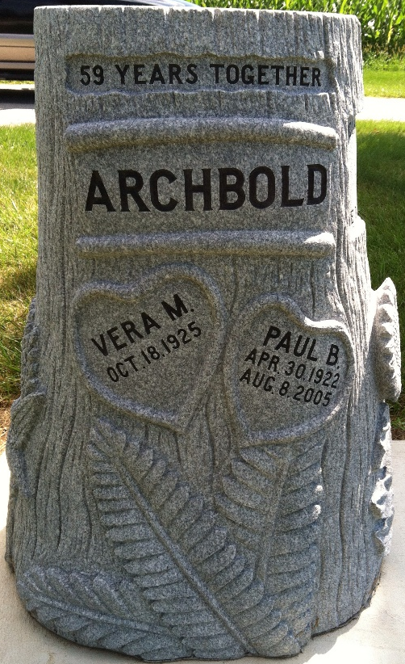
Photo by Barbara Baker Anderson

VERA M. ARCHBOLD, 88, of Ossian, passed away on Tuesday, Dec. 10, 2013. Born Oct. 18, 1925, in LaOtto, Ind., she was a daughter of the late Curtis and Gladys (Frankenberg) Christlieb.
She worked for Uniondale Telephone and later retired from Alltel. She enjoyed feeding the birds and tending her flowers.
Surviving family include her children, Ted (Linda) Archbold and Vicki (Tom) Brown; brother, Vern Cristlieb; six grandchildren; and eight great-grandchildren. She was also preceded in passing by her husband, Paul Archbold; and a sister, Lois Smith.
Funeral service is 11am Saturday, Dec. 14, 2013, at Elzey-Patterson-Rodak Funeral Home, 120 West Mill St., Ossian, with visitation one hour prior. Visitation also from 2-4 and 6-8pm Friday, Dec. 13, 2013, at the funeral home. Burial in Oak Lawn Cemetery. Memorials may be made to Riley Children's Hospital or the American Cancer Society.

Fort Wayne Newspapers, Allen County, Indiana
Dec. 12, 2013

