Tommy Archbold, Jr.
May 8, 1920 – January 16, 1940

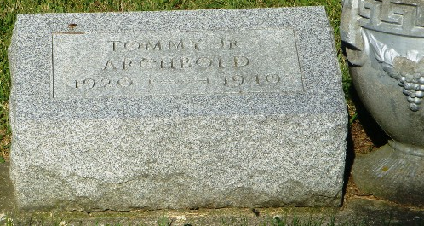
Photo by HoosierGirl88

ARCHBOLD
Bluffton, Jan. 16 – Thomas Archbold, Jr., 19, a junior in the Ossian High School died at 10:15 am today at the home of the parents, Mr. and Mrs. Thomas Archbold, one and one fourth miles east of Ossian following an illness of diabetes.
Surviving are the parents, two sisters, Mrs. Carl Mosser of Fort Wayne and Golden Louise Archbold at home and three brothers, Max Archbold of Fort Wayne, Jack Archbold of Yoder and Howard Archbold at home.
Funeral services will be held at 2 pm Thursday at the Ossian Presbyterian Church. Burial will be in the Oak Lawn Cemetery at Ossian.
Journal-Gazette, Allen County, Indiana
January 17, 1940

