Thomas W. Archbold
October 4, 1834 – July 9, 1920

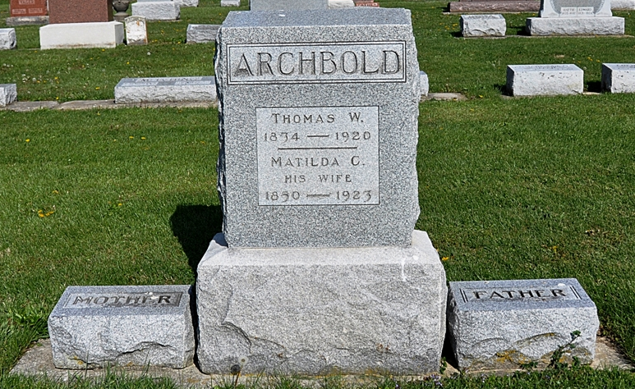
Photo by Deb Curry

Indiana, U.S., Death Certificates, 1899-2017
Name Thomas W Archbald
Gender Male
Race White
Marital Status Married
Age 85y 9m 5d
Birth Date 4 Oct 1834
Birth Place Ohio
Death Date 9 Jul 1920
Death Place Fort Wayne, Allen, Indiana, USA
Death Registration Date 1920
Father Joseph Archbald
Mother Eleyla Aronholt
Spouse Malilda Archbald
Informant John or Joan Archbold
Burial Ossian, Ind. 7/11/1920

**
Thomas W. Archbold

It is always pleasant and profitable to contemplate the career of a man who has made a success of life and won the honor and respect of his fellow citizens. Such is the record of the well know farmer whose name heads this sketch, than whom a more whole-souled or popular man it would be hard to find within the limits of the township in which he resides. He is one of the old settlers of Jefferson township, Wells county, Indiana, and was born to Joseph and Elwyla (Van Horn) Archbold, in Tuscarawas county, Ohio, October 4, 1834. The Arch-bold family are of Irish descent, the grandfather, Patrick Archbold, having been born and reared in that country. In early manhood he emigrated to America, the Mecca for all expanding young life, and settled in Harrison county, Ohio, where he met and married Miss Francina McClain, a fellow country-woman. Becoming dissatisfied with his life in Ohio, he brought his wife to Jefferson township, Indiana, in the spring of 1848, remaining here until his death at upwards of eighty years old.
Joseph Archbold had come to Jefferson township in October, 1847, just one year before the emigration of his father, and entered land in section thirty and immediately began to improve it, residing there until his death. He had always been a hard working man and it was owing to his industry that during his life he was able to accumulate a comfortable fortune being the possessor of one hundred and fifty-two acres of fine farmland. He was a Presbyterian of strict belief and died in the faith which in life he had supported. His children numbered fourteen, nine daughters and five sons, namely: Isaac, Patrick, William J., Thomas W., Rachael, Lucinda and Malinda (twins), Francina, Lucina, Catharine, Elizabeth, Ellen and Barbara. [only 13 named) Barbara was the most fortunate member of this large family of children. Being the youngest she was able to obtain many educational advantages which were denied the others and it was through the efforts of her brother, Thomas, that her education was cared for. For some time she followed the vocation of teaching with success and always looked to her brother who had been the means of obtaining for her the advantage of an education, as her best friend and guide. She is now the wife of John Engle.
Thomas W. Archbold was reared on his father’s farm and, owing to a large family of which he was one of the eldest, he received almost no education. In those days the older boys were kept at home clearing the farm and tending the crops in order that the family might exist in the great wilderness and he was no exception to the rule for he kept steadily at work on the home place, carefully nurturing his longing for the knowledge that had been denied him, until he was twenty-six years old, when he took a short term with M. C. Blue as teacher and later entered the Roanoke Academy, where he attended three terms, getting a sufficient education to enable him to teach in the common schools of Wells county. He continued to teach in the Jefferson township schools for ten years.
March 14, 1867, Mr. Archbold was married to Miss Matilda C. Miller, daughter of Henry and Nancy (Kunkel) Miller. Mrs. Archbold was born in Crawford county, Ohio, in 1850 and had received a common school education. They were the parents of seven children: Alonzo H., resides at Markle, Indiana; Nancy, wife of N. Q. Hildenbrand; Lydia, wife of Charles Crowel; Clayton, William, Stella and Clifton.
Mr. Archbold was poor when he married, having only a small farm of one hundred and twenty acres which he sold and later purchased the old Johnson farm two and one-half miles south of Ossian where he now resides. His advancement was due not to a lucky stroke of fickle fortune but by his own untiring efforts and his determination to win. He was a teamster for one year during the Civil war. In the early days he had been a great hunter and trapper in Wells county, especially along the Eight Mile. He is a most moral man and, while not a church worker, having never united with any denomination, yet he commends all good works be they of a religious or secular nature. In political affairs he has ever been identified with the Democratic party, being an active and ardent worker for the cause, although never having been an office seeker. He was at one time a member of the Wells county central committee and has also served on the election board for twenty-five years. He is not only well and favorably known in Jefferson township but throughout Wells county. He is known as a man of unimpeachable honor and integrity, honest motives and intelligence. He is one of the best citizens of the county and enjoys the highest regards of his acquaintances.

Biographical Memoirs of Wells County, Indiana; B. F. Bowen Publisher, Logansport, IN, 1903 Pg. 488-490.

