Thomas T. Archbold
February 14, 1876 – December 10, 1961

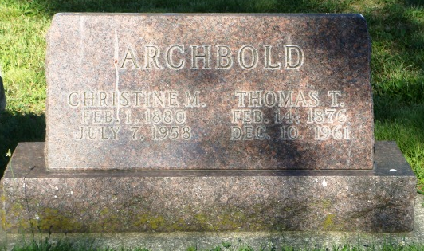
Photo by HoosierGirl88

Thomas Archbold Dies at Age of 85

Thomas (Floss) Archbold, 85, a resident of Ossian until three years ago, died at 7 1.m. Sunday at the home of a daughter, Mrs. Frederick Lehman of Berne.
The son of Robert and Druzilla Metts Archbold, Mr. Archbold was born Feb. 14, 1876 in Jefferson Twp. His marriage to Christine Mackey, who died in 1958, took place December 27, 1906. Mr. Archbold, a retired farmer, was a member of the Ossian Presbyterian Church.
Surviving, in addition to Mrs. Lehman, are another daughter, Mrs. Carl Mosser of Fort Wayne; three sons, Maxwell of Fort Wayne Route 2, Robert of Uniondale Route 1 and Howard of Ossian, Route2; a brother Harry of Fort Wayne; 10 grandchildren and one great-grandson.
Friends may call after 7 p.m. today at the Elzey Funeral home at Ossian. Services will be held at 10 a.m. Wednesday at the funeral home with Rev. Milton Nolin officiating. Burial will be in the Oaklawn Cemetery.

Unknown newspaper clipping

