Theodore Wilson Archbold
April 18, 1866 – December 12, 1925

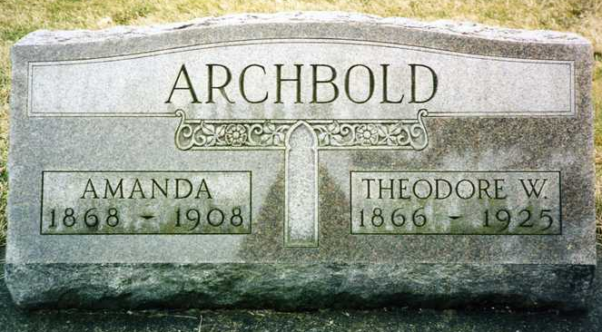
Photo by drbuck

Indiana, U.S., Death Certificates, 1899-2017
Name Theodore W. Archbold
Gender Male
Race White
Marital Status Widowed
Age 59y 7m 24d
Birth Date 18 Apr 1866
Birth Place Indiana
Death Date 11 Dec 1925
Death Place Jefferson, Wells, Indiana, USA
Death Registration Date 1925
Father William J Archbold
Mother Lovina Yarger Archbold, informant
Spouse Amanda Archbold
Burial Ossian, IN 12/14/1925

