Lovina (Yarger) Archbold-Smith
July 10, 1843 – February 14, 1924

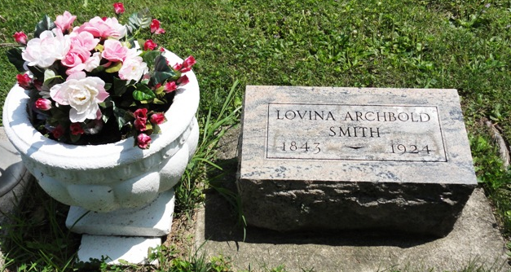
Photo by Kay Bradtmiller

Lovina Smith
in the Indiana, U.S., Death Certificates, 1899-2017

Name Lovina Smith
[Lovina Yarger]
Gender Female
Race White
Marital Status Married
Age 80
Birth Date 10 Jul 1843
Birth Place Ohio
Death Date 14 Feb 1924
Death Place Jefferson, Wells, Indiana, USA
Father Yarger
Mother Beal
Spouse Jacob Smith
Informant T. W. Archbold; Ossian, Indiana
Burial February 16, 1924; Ossian, Indiana
**

Lovina Yarger from tree Grate Tree

Birth 10 Jul 1843 Richland, Allen, Ohio, USA
Marriage 13 Jun 1865 Wells, Indiana, USA
Residence 1920 Wells, Indiana, USA
Death 13 Feb 1924 Wells, Indiana, USA
Father David Yarger (Born 1797)
Mother Elizabeth Maria Beal (Born 1815)
Spouse William John Archbold (1832-1870)
Spouse Jacob Smith

