Robert Jack Archbold
August 8, 1910 – April 14, 2000

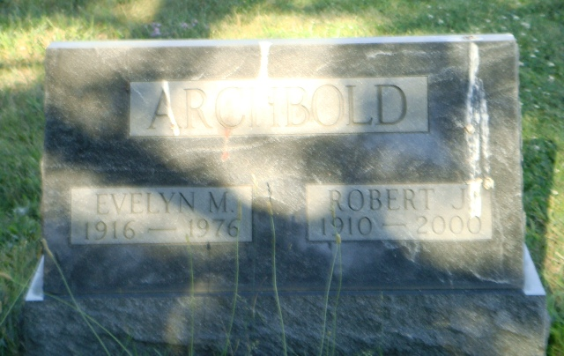
Photo by Kay Bradtmiller

Robert Jack Archbold, 89, of Fort Wayne, a longtime resident, died Friday, April 14, 2000, in Fort Wayne. The Ossian native retired in 1970 from General Electric as an employment specialist after 42 years of service.
Surviving are his wife, Agnes; a son, Steven J. of Springfield, Ohio; a daughter, Linda L. Brown of Columbia City; a sister, Virginia Mosser of Fort Wayne; five grandchildren; and two great-grandchildren. He was preceded in death by his first wife, Evelyn; a sister, Golden Lehman, and brothers, Thomas, Max and Howard.
Services were 2 p.m. today at D.O. McCombs & Sons Maplewood Park Funeral Home, 4017 Maplecrest Road. Burial was at Oaklawn Cemetery, Ossian.
Memorials are to the American Heart Association or the American Lung Association.

News-Sentinel, Allen County, Indiana
Monday, April 17, 2000

