Paul B. Archbold
April 30, 1922 – August 8, 2005

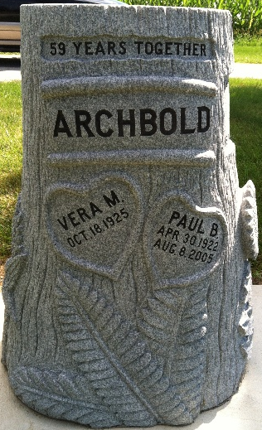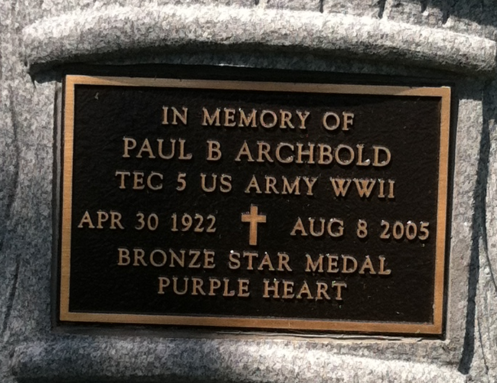
Photos by Barbara Baker Anderson

Paul B. Archbold, 83, of rural Ossian, died at Bluffton Regional Medical Center Monday, Aug. 8. Born April 30, 1922 in Wells County to Marvin and Iva Woods Archbold, his marriage to the former Vera M. Christlieb took place Feb. 15, 1946 in Lebanon. She survives.
An interior decorator for 20 years, he was also a farmer and mail carrier for 25 years. He was a World War II veteran of the United States Army and a member of the Grover Sheets American Legion Post 111.
In addition to his wife, he is survived by a son, Ted, of Ossian; a daughter, Mrs. Tom (Vicki) Brown of Ossian; a brother, Glen Archbold of Fort Wayne; six grandchildren and six great-grandchildren. He was preceded in death by two sisters and a brother.
Services at 11 a.m. Thursday will be under the direction of Rev. Chad Finney at Elzey-Patterson-Rodak Funeral Home, Ossian. Burial will be at Oaklawn Cemetery, Ossian. Calling will be from 2-4 p.m. and 6-8 p.m. Wednesday and one hour prior to services Thursday at the funeral home.
Memorials may be made to the Caylor-Nickel Foundation or to Riley Children's Hospital.

Bluffton News-Banner, Wells County, Indiana
Tuesday, Aug. 9, 2005

