Patty Lou Archbold
May 29, 1959 – November 8, 1966

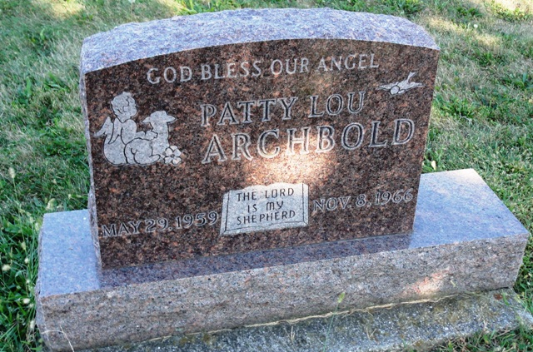
Photo by HoosierGirl88

Indiana, U.S., Death Certificates, 1899-2017
Name Patty Lou Archbold
Gender Female
Race White
Age 7
Birth Date 29 May 1959
Birth Place Fort Wayne, Indiana
Death Date 8 Nov 1966
Death Place Warsaw, Kosciusko, Indiana, USA
Cause of death Respiratory failue
Death Registration Date 1966
Father Gerald O Archbold, informant
Mother Betty Angus
Burial 11/10/1966 Oak Lawn Cemetery

