Georgia May (Stepler) Archbold-Norwood
September 5, 1899 – April 19, 1984

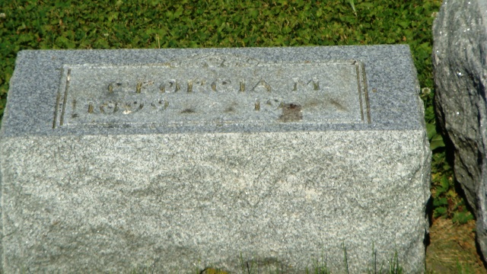
Photo by drbuck Photo by HoosierGirl88

Indiana, U.S., Death Certificates, 1899-2017
Name Georgia M. Norwood
[Georgia M. Stepler]
Gender Female
Race White
Marital Status Widowed
Age 84
Birth Date 5 Sep 1899
Birth Place Indiana
Death Date 19 Apr 1984
Death Place Peru, Miami, Indiana, USA
Death Registration Date 1984
Father John Stepler
Mother Mary Murden
Informant Catherine Darrow
Burial Friends Cemetery, Amboy, IN 4/21/1984

