Nellie Irene Archbold
August 15, 1915 – May 12, 1918

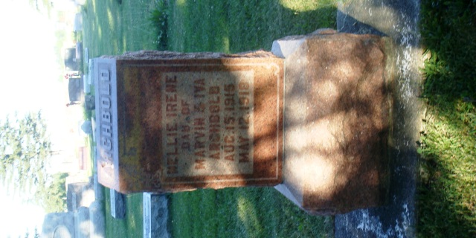
Photo by HoosierGirl88

Indiana, U.S., Death Certificates, 1899-2017
Name Nellie Irene Archbold
Gender Female
Race White
Marital Status Single
Age 2y 9m 2d
Birth Date 10 Aug 1915
Birth Place Allen County, Indiana
Death Date 12 May 1918
Death Place Assinins, Wells, Indiana, USA
Death Registration Date 1918
Father Marvin Archbald, informant
Mother Iva Woods
Burial Ossian Cem 5/14/1918

