Minnie Dell (Nevius) Archbold
August 2, 1871 – May 18, 1937

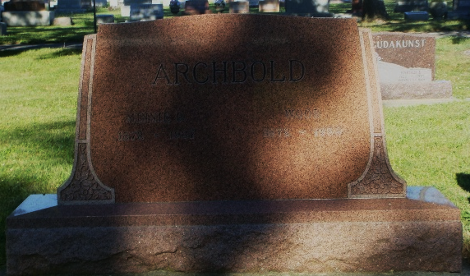
Photo by HoosierGirl88

Indiana, U.S., Death Certificates, 1899-2017
Name Minnie Dell Archbold
[Minnie Dell Nevius]
Gender Female
Race White
Marital Status Married
Age 65y 9m 16d
Birth Date 2 Aug 1871
Birth Place Indiana
Death Date 18 May 1937
Death Place Lancaster, Wells, Indiana, USA
Death Registration Date 1937
Father George R Nevius
Mother Emily Murphy
Spouse Wood Archbold, informant
Burial Ossian, Ind. 5/20/1937

