Michael Thomas Archbold
August 5, 1965 – August 5, 1965

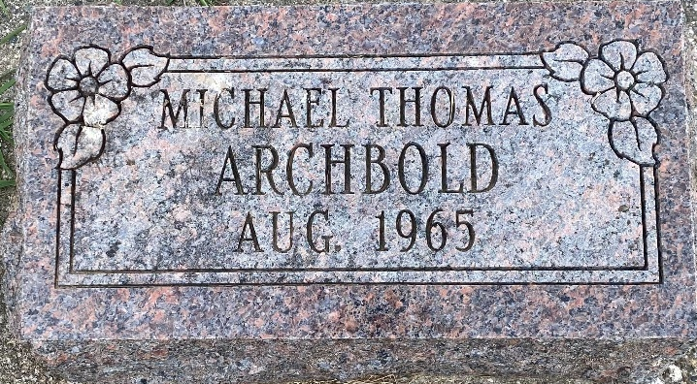
Photo by HoosierGirl88

Graveside Services Held for Archbold Boy

Graveside services were held today in Oak Lawn Cemetery in Ossian for Michael Thomas Archbold, son of Mr. and Mrs. Steven Archbold of Ossian, who died at birth at 5:38 p.m. Thursday at Lutheran Hospital.
Rev. Jerry Fair officiated and Elzey Funeral Home was in charge of the arrangements.
Surviving, in addition to the parents, are the grandparents, Mr. and Mrs. Robert Archbold of Uniondale Route 1 and Mr. and Mrs. Eugene Johnson of Yoder Route 1.

Bluffton News-Banner, Wells County, Indiana
Friday, August 6, 1965, Page 3, Column 2

