Matilda C. (Miller) Archbold
March 24, 1850 – May 13, 1923

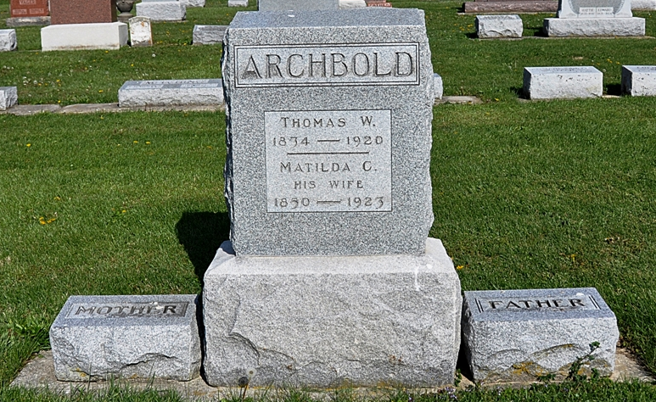
Photo by Deb Curry

Indiana, U.S., Death Certificates, 1899-2017
Name Maltilda C. Archbold
[Maltilda C. Miller]
Gender Female
Race White
Marital Status Widow
Age 73y 1m 19d
Birth Date 24 Mar 1850
Birth Place Ohio
Death Date 13 May 1923
Death Place Fort Wayne, Allen, Indiana, USA
Death Registration Date 1923
Father Henry Miller
Mother Nancy Kunkle
Spouse Thomas Archbold
Informant Mrs. Quincy Hildebrand
Burial Ossian, Indiana 5/15/1923

