Mary Cathrine (Sommers) Archbold
May 7, 1843 – February 3, 1910

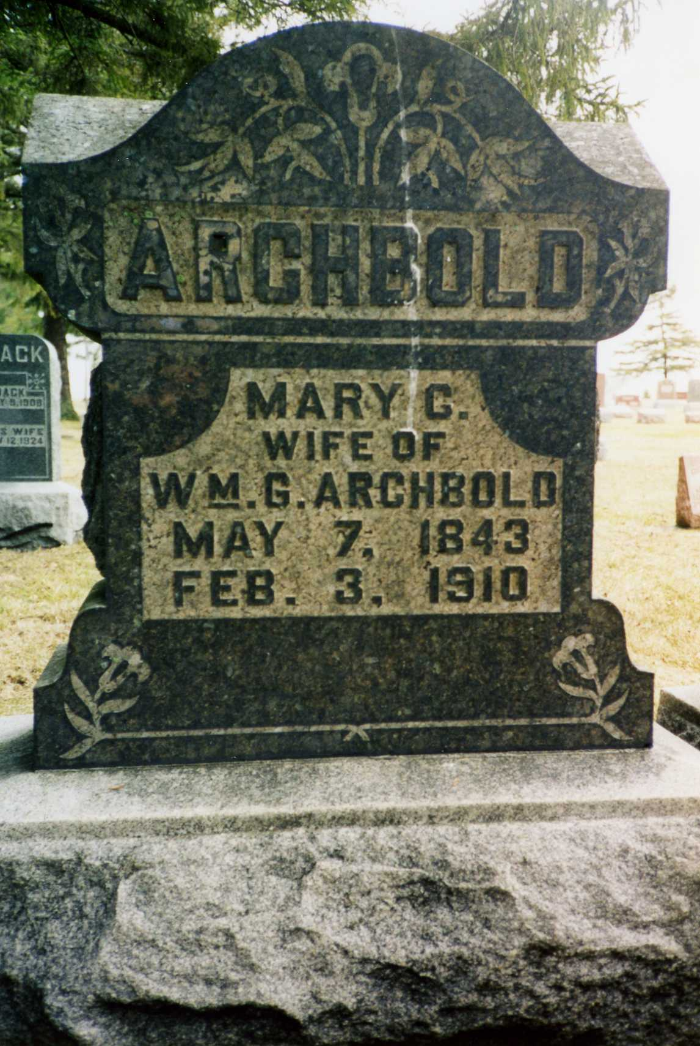
Photo by drbuck

Indiana, U.S., Death Certificates, 1899-2017
Name Marry K Archbold (indexed as Archbald)
[Marry K Sammen]
Gender Female
Race White
Age 66y 8m 26d
[66]
Birth Date 7 May 1843
Birth Place Allen Colorado
Death Date 3 Feb 1910
Death Place Wells, Indiana, USA
Death Registration Date 1910
Father William Summers
Mother Amline Rock
Spouse Mary R Archbald
Informant too faded to read
Burial Ossian, Ind. 2/5/1910

**
Poe News - A. J. Archbold attended the funeral of his aunt, Mrs. Mary C. Archbold, at Ossian last Saturday.

Fort Wayne Weekly Sentinel, Allen Co, Indiana
Wednesday, February 9, 1910

**
Indiana Deaths, 1882-1920

Name: Mary K. Archbold
Date: Feb 01, 1910 Location: Wells County
Age: 66 yr Gender: Female Race: W
Source location: County Health Office, Bluffton
Source notes: The source of this record is the book H-5 on page 47 within the series produced by the Indiana Works Progress Administration.

**
Wells County Cemetery Index (George Archbold 2nd wife)

Last Name: Archbold; First Name: Mary C.
Cemetery: Oak Lawn
Died: 02-03-1910; Age: *
Born: 05-07-1843
Source: W

