Martha Elizabeth (Glawe) Archbold
December 12, 1886 – December 23, 1963

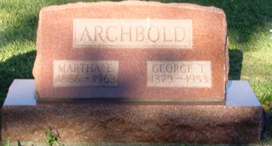
Photo by HoosierGirl88

Martha T. Archbold

Fort Wayne – Mrs. Martha E. Archbold, 77, a native of Edgerton, died at 4:05 p.m. Monday in Parkview Memorial Hospital. She had been ill since April.
Surviviors (sic) include four daughters; a son; a sister, Mrs. Emma Watson, Fort Wayne; 10 grandchildren; and five great grandchildren.
Services will be at 11 a.m. Thursday in the D. O. McComb and Sons funeral home with burial in Oaklawn cemetery, Ossian.

Defiance Crescent-News
Tuesday, December 24, 1963

