Mae (Glass) Archbold
February 4, 1881 – May 2, 1956

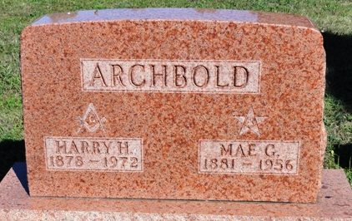
Photo by Kay Bradtmiller

May Glass from tree Glass Family Tree
Birth Feb 1881 Indiana, USA
Marriage 25 Oct 1919 Wells, Indiana, USA
Residence 1940 Wells, Indiana, USA
Death 2 May 1956 Waynedale, Allen, Indiana, USA
Father George W Glass (1844-1917)
Mother Eliza H. Ryan (1840-1929)
Spouse Harry Hildreth Archbold (1878-1972)
609 People 7 Records 7 Sources
**
Indiana, U.S., Marriages, 1810-2001
Name May Glass
Gender Female
Race White
Age 38
Event Type Marriage Registration (Marriage)
Birth Date 4 Feb 1881
Birth Place Ossian, Indiana
Marriage Date 25 Oct 1919
Marriage Place Indiana, United States
Residence Place Ossian, Indiana
Father George Glass
Mother Eliza H Ryan
Spouse Harry Gildreth Archbold
Page 76
FHL Film Number 002318976

