Linda (Bobilya) Archbold
February 18, 1947 – May 11, 2025

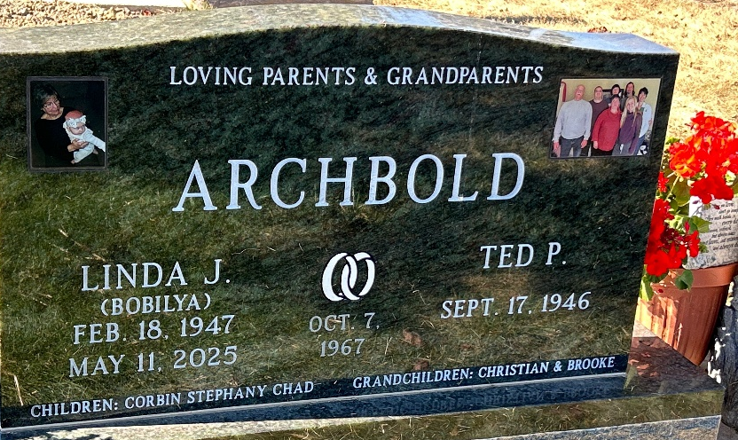
Photo by Barbara Baker Anderson

Linda Archbold, 78, of Ossian, passed away on Sunday, May 11, 2025. She was born in Fort Wayne on Feb. 18, 1947, a daughter of the late Theodore and Josephine (Crosby) Bobilya. Linda had a passion for gardening, making wedding and birthday cakes, and most of all, spending time with her grandchildren. She was an amazing cook no matter what she made.
Linda is survived by her husband of 57 years, Ted Archbold; sons, Corbin and Chad Archbold; grandchildren, Christian Archbold and Brooke Bartels; great-granddaughter, Opal Bartels; and sister, Kathy (David) Sult.
She was preceded in passing by her daughter, Stephany Romines; and brothers, Edward and Michael Bobilya.
All services will be private and Linda will be laid to rest at Oak Lawn Cemetery. Services provided by Elzey-Patterson-Rodak Funeral Home.
Contributions in Linda’s memory may be made to Cancer Services of Northeast Indiana.

News Banner, Wells County, Indiana
May 15, 2024

