Joseph William Archbold
January 8, 1878 – October 2, 1956

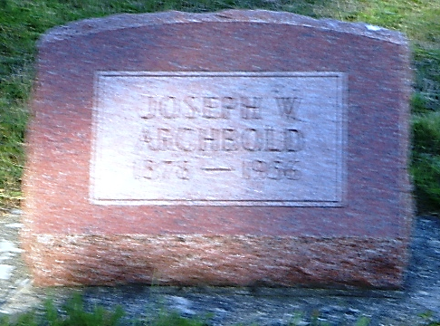
Photo by Kay Bradtmiller

U.S., Social Security Applications and Claims Index, 1936-2007
Name Joseph William Archbold
Gender Male
Race White
Birth Date 8 Jan 1878
Birth Place Bluffton, Indiana
Father Emmet Archbold
Mother Louisa Caid
SSN xxx
Notes Jun 1937: Name Listed As Joseph William Archbold
**
Indiana, U.S., Marriage Certificates, 1960-2012
Name Joseph W Archbold
Gender Male
Race White
Birth Place Wells, Indiana
Marriage Date 7 Nov 1901
Marriage Place Adams, Indiana, USA
Residence Place Indiana
Father Enrnvett Archbold
Mother Louisa Caid
Spouse Ivy B Rupright
Officiator G H Hutchison
**
, Wells, Indiana Cemetery Index
Last Name: Archbold
First Name: Joseph W. Obituary:
Cemetery: Oak Lawn
Died: 10-02-1956 Age: 78
Born: 01-08-1878
Source: OCWF
Funeral: Elzey

