Ivy Belle (Rupright) Archbold
October 25, 1881 – July 8, 1924

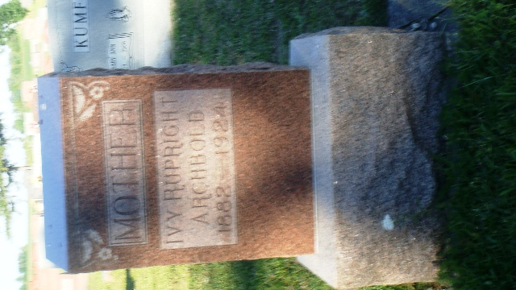
Photo by Kay Bradtmiller

Decedent's Name Archbold, Iva B
Date of Death July 8, 1924
Died at Residence
Sex F
Color W
Marital status Married/widowed
Age 42y 9m 13d
Birth Oct 2, 1881
Birth place Indiana
Father Wentz Rupright
Mother Mary Short
Burial Ossian, Ind. 7-10-1924

Unknown Fort Wayne, Indiana record

**
Iva Belle "Ivy" Rupright from tree Debbie Elkins family tree
Birth 25 Oct 1881 Adams, Indiana, USA
Marriage 7 Nov 1901 Allen, Indiana, USA
Residence 1920 Wells, Indiana, USA
Death 8 Jul 1924 Indiana, USA
Father Granville Wentz Rupright (1851-1920)
Mother Mary Florence "Mollie" Short (1854-1917)
Spouse Joseph William Archbold (1878-1956)
11077 People 4 Records 29 Sources

