Howard M. Archbold
July 17, 1912 – June 26, 1984

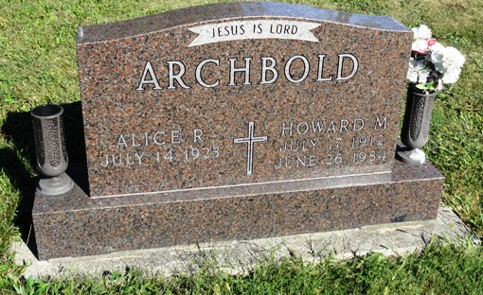
Photo by HoosierGirl88

Indiana, U.S., Death Certificates, 1899-2017
Name Howard M. Archbold
Gender Male
Race White
Marital Status Married
Age 71
Birth Date 17 Jul 1912
Birth Place Indiana
Death Date 26 Jun 1984
Death Place Fort Wayne, Allen, Indiana, USA
Death Registration Date 1984
Father Thomas Archbold
Mother Christine Mackey
Spouse Alice (Bowers) Archbold, informant
Burial Oak Lawn Cemetery 6/28/1984

