Homer H. Archbold
January 17, 1893 – February 26, 1975

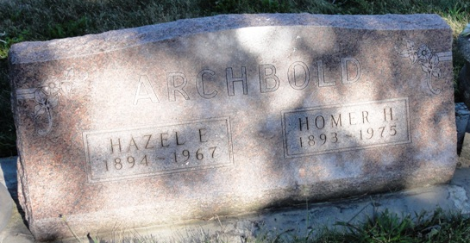
Photo by Kay Bradtmiller

Indiana, U.S., Death Certificates, 1899-2017
Name Homer H Archbold
Gender Male
Race White
Marital Status Widowed
Age 82
Birth Date 17 Jan 1893
Birth Place Indiana
Death Date 26 Feb 1975
Death Place Bluffton, Wells, Indiana, USA
Death Registration Date 1975
Father Emmett Archbold
Mother Louisa Caid
Informant Gerald Archbold, son
Burial Oak Lawn Cemetery, 3-1-1975

