Harry Hildreth Archbold
June 29, 1878 – December 22, 1972

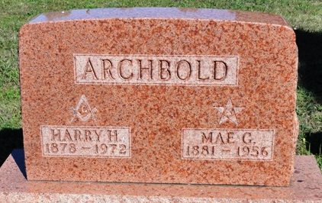
Photo by Kay Bradtmiller

Harry H. Archbold, 94, died today at the Allen County Health Center. He was a retired farmer and former maintenance man at Baer Field for 20 years. Born June 29, 1878 in Wells County, he was the son of Thomas and Zill Metts Archbold. He was married to Mae Glass who died May 2, 1956. He was a member of the Ossian Presbyterian Church.
Surviving are two nieces and three nephews.
Services will be Sunday at the Elzey Funeral Home in Waynedale with burial in Oak Lawn Cemetery in Ossian; Rev. James Woodworth officiating.

Wells County, Indiana Obituaries
1969 – 1975
(December 22, 1972)

