Harold E. Archbold
January 13, 1918 – December 2, 2003

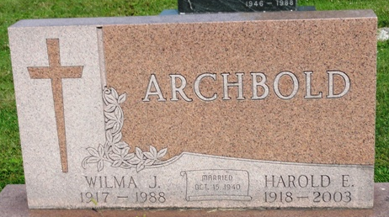
Photo by Kay Bradtmiller

Harold E. Archbold, 85, of Ossian, died Tuesday, Dec. 2, 2003, at Ossian Health Care & Rehab. Born Jan. 13, 1918, in Wells County, he was a retired farmer and painting contractor. He was a member of the Ossian Church of the Nazarene.
Survivors include sons, Dean E. (Pat) Archbold of Bluffton, Lyle G. (Janelle) of Ridgetown, Ontario, Canada; daughter, Marilyn Lindquist of Farmington, Conn.; sisters, Joan Brewer of Bluffton, Luella Updike of Warren; seven grandchildren and 11 great-grandchildren. He was preceded in death by his wife, Wilma, in 1988.
Service is 10:30 a.m. Saturday at Ossian Church of the Nazarene, 302 N. Metts St., Ossian. Visitation is from 2 to 5 and 7 to 9 p.m. Friday at Elzey-Patterson-Rodak Funeral Home, 120 W. Mill St., and one hour prior to service at the church. Burial at Oaklawn Cemetery, Ossian. Memorials to American Diabetes Association or the church.

News-Sentinel, Allen County, Indiana
Thursday, December 4, 2003

