Golden Gaynell Archbold
February 10, 1887 – December 26, 1958

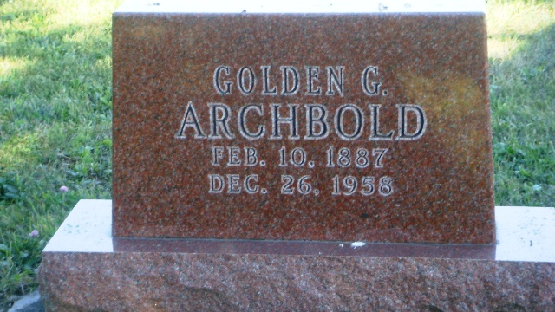
Photo by HoosierGirl88

Indiana, U.S., Death Certificates, 1899-2017
Name Golden Archbold
Gender Female
Race White
Marital Status Single
Age 71
Birth Date 10 Feb 1887
Birth Place Indiana
Death Date 26 Dec 1958
Death Place Bluffton, Wells, Indiana, USA
Death Registration Date 1958
Father Robert Archbold
Mother Miranda Metts
Informant Jack Archbold, nephew
Burial 12/28/1958Oak Lawn Cem.

