Glen E. Archbold
September 17, 1917 – March 3, 2008

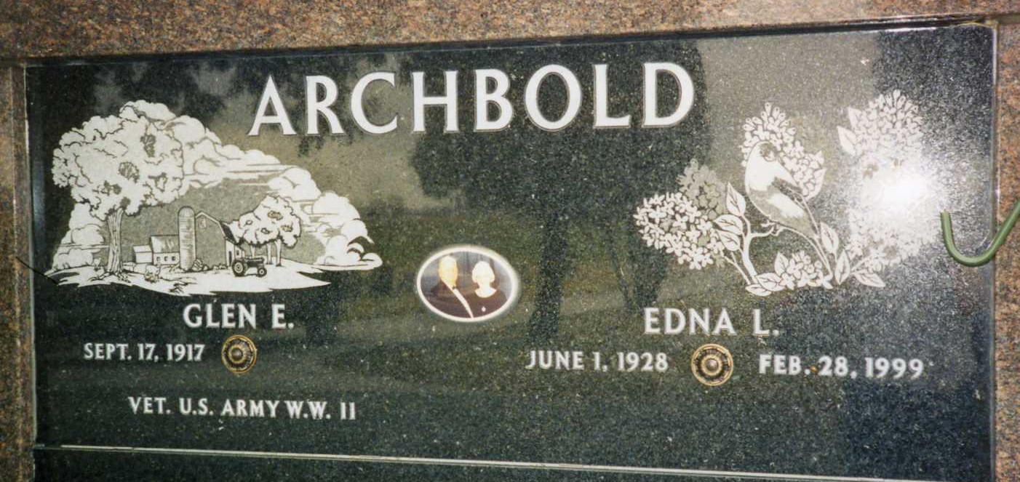
Photo by drbuck

Former Ossian resident, Glen E. "Archie" Archbold, 90, died Monday, March 3, 2008, at his daughter's home in Fort Wayne. He was born to Marvin and Iva Woods Archbold.
He served in the Philippines for four years in U.S. Army during World War II. He worked for General Electric as an inspector for 30 years and retired, having previously worked at Dana in Fort Wayne. He was a member of IUE-CWA Local 901, American Legion Post 111, VFW, Moose and G.E. Quarter Century Club. He attended the Ossian Church of the Nazarene.
He was preceded in death by his wife of 49 years Edna Jones Archbold in 1999; two brothers, Paul Archbold and Ned Archbold; and one sister, Mary Dafforn.
Funeral services will be at 2 p.m. Thursday at Elzey Patterson Rodak Funeral Home in Ossian. Visitation will be Wednesday from 4 p.m. to 8 p.m. and one hour prior to funeral. Burial will be at Oak Lawn Cemetery in Ossian, with a military service by American Legion Post 111. Pastor James Cress will officiate.
Preferred memorials are to Parkview Home Health and Hospice or the Ossian Church of the Nazarene.

Bluffton News-Banner, Wells County, Indiana
Tuesday, March 4, 2008

