Georgiana Lillian Archbold
September 3, 1907 – November 20, 1908

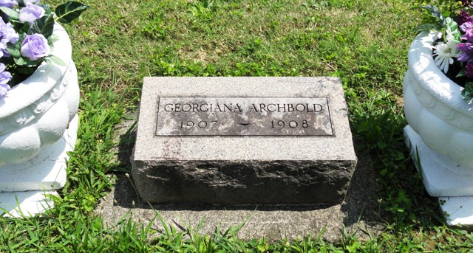
Photo by HoosierGirl88

Georgina Lillian Archbold from tree LaRue, Downing, Collins, Baughman Family Tree
Birth 3 Sep 1907 Ossian, Wells, Indiana, USA
Death 20 Nov 1908 Ossian, Wells, Indiana, USA
Father Theodore Wilson Archbold (1866-1925)
Mother Amanda Jane Stubbs (1868-1908)
17176 People 0 Records 8 Sources

