George Thomas Archbold
November 6, 1879 – April 1, 1953

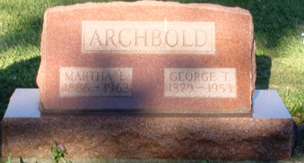
Photo by HoosierGirl88

GEORGE T. ARCHBOLD
George Thomas Archbold, 73, 1429 Vance Ave., died at 12:20 a.m. yesterday in the St. Joseph's Hospital. He had been a patient there for the past 16 days. Mr. Archbold was a retired construction worker and a lifelong resident of Fort Wayne.
Survivors are his wife, Martha E.; one son, Howard R., Yellow Springs, O.; four daughters, Mrs. Gertrude Burtnette, Mrs. Florence Falardau and Mrs. Joan Yost, all of Fort Wayne, and Mrs. Gladys Hunt, Portland; three brothers, Joseph, Fort Wayne, Homer H., Ossian, and Harold O., Uniondale; one sister, Mrs. Mary Crowe, Ossian; six grandchildren and one great-grandchild.
Friends may call at the D. O. McComb & Sons Funeral Home after 7 p.m. today. Services will be Saturday at 1:30 p.m. in the funeral home, the Rev. Owen McGarity officiating. Burial will be in Oak Lawn Cemetery, Ossian.
Fort Wayne Journal Gazette, Allen County, Indiana
Thursday April 2, 1953

