George M. Archbold
June 10, 1901 – September 30, 1983

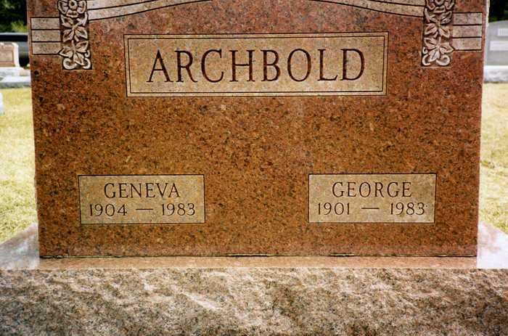
Photo by drbuck

GEORGE M. ARCHBOLD, 82 DIES; SERVICES SET MONDAY
A retired painter and farmer, George M. Archbold, 82, of Ossian Route 4, died at 12:50 p.m. Friday at Ossian Health Care Center where he had been a resident the last three weeks.
Born June 10, 1901, at Ossian, he was a son of Emmett and Mary Valentine Archbold. His marriage June 29, 1929, at Bluffton was to Ganet (sic) Geneva Heckley, who survives.
Mr. Archbold was a member of Faith United Methodist Church and the Ossian Masonic Lodge for over 50 years.
Calling will be from 2 to 5 and 7 to 9 p.m. Sunday at Elzey-Dickey-Haggard Funeral Home in Ossian where services will be at 1:30 p.m. Monday. Rev. Paul Frederick will officiate. Burial will be in Oak Lawn Cemetery in Ossian. Preferred memorials are to the donor's favorite charity.

Bluffton News-Banner, Wells County, Indiana
Saturday, November 1, 1983, p. 3, col. 1

