Gale E. Archbold
July 29, 1923 – August, 1946

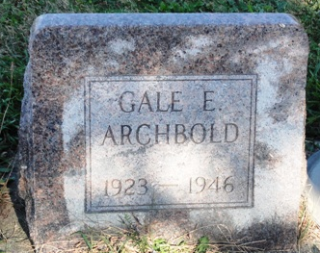
Photo by HoosierGirl88

Indiana, U.S., Birth Certificates, 1907-1944
Name Archbold
Gender Male
Birth Date 29 Jul 1923
Birth Place Jefferson, Wells, Indiana, USA
Father Homer Archbold
Mother Hazel Fonner
Certificate Number 39087; Roll number 40474_357316
Volume Range 76 – 80

**
Indiana, U.S., Marriages, 1810-2001
Name Gale Archbold
Gender Male; Race White; Age 20
Birth Date 30 Jul 1923; Birth Place Wells, Indiana
Marriage Date 20 Mar 1943; Marriage Place Indiana, United States
Residence Place Yoder, Indiana
Father Homer Archbold
Mother Hazel Fonner
Spouse Georgia Hampe Or Hamji
Page 358
**
Web: Allen County, Indiana, U.S., Obituary Index, 1841-2010
Name Gale Archbold
Publication Date 19 Aug 1946
Publication Place Allen, Indiana, United States of America
Death Date Abt 1946
URL http://friendsofallencounty.org/search_obits1900.php

