Iva Geneva (Woods) Archbold
August 1, 1893 – February 26, 1951

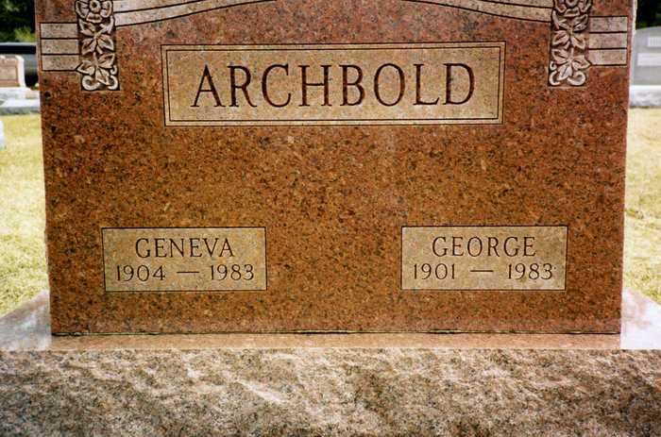
Photo by drbuck

Indiana, U.S., Death Certificates, 1899-2017
Name Garnet Geneva Archbold
[Garnet Geneva Heckley]
Gender Female
Race White
Marital Status Widowed
Age 79
Birth Date 7 Jun 1904
Birth Place Indiana
Death Date 16 Oct 1983
Death Place Decatur, Adams, Indiana, USA
Death Registration Date 1983
Father Franklin Heckley
Mother Kattie Jane Judd
Burial 10/18/1983 Oak Lawn Cemetery

