Forrest Ray Archbold
March 25, 1892 – May 5, 1925

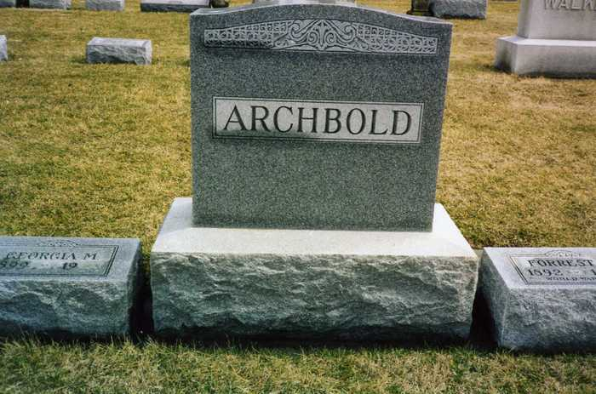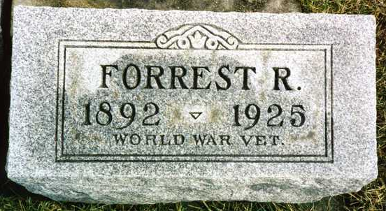
Photos by drbuck

WELLS COUNTY MAN DIES OF INJURIES
Forrest Archbold Suffers Fractured Skull When He Falls From Train

Bluffton, Ind., May 5.-Forrest Archbold, 32, of Fort Wayne, died at 10 o’clock this morning in the City Hospital at Bluffton, O., of injuries received at 6 o’clock this morning in an accident on the Lake Erie & Western Railway at Bluffton.
He was employed as a brakeman. In passing the Bluffton station on a fast freight, he leaned out to grab a large ring to which train orders were attached, and in doing so lost his hold and fell from the train. He suffered a fractured skull when his head struck the end of a crosstie. His right foot fell across a rail and the toes were ground off.
Surviving besides the widow are the parents, Mr. and Mrs. Emmet Archbold, living near Ossian, three brothers and two sisters, all living near Ossian. The deceased was a World War veteran.

Muncie Morning Star, Delaware County, Indiana
Wednesday, May 6, 1925

**
Bluffton, Ind., May 6.-The body of Forrest Archbold, of For Wayne, who was killed when he fell from a Nickel Plate train at Bluffton, O., yesterday morning, was brought today to the home of the parents, Mr. and Mrs. Emmet Archbold, near Ossian.
Funeral services will be held at 2 o’clock Friday afternoon at the Ossian M. E. Church, and burial will be at the Oaklawn Cemetery…

The Star Press, Muncie, Indiana
Thursday May 7, 1925

