Emma Louise (Souers) Archbold
January 5, 1898 – February 27, 1988

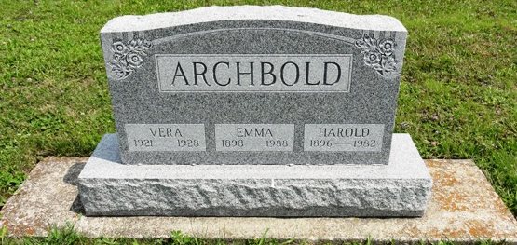
Photo by HoosierGirl88

U.S., Social Security Applications and Claims Index, 1936-2007

Name Emma Louise Archbold
[Emma L Archbold]
[Emma Louise Souers]
Gender Female
Race White
Birth Date 5 Jan 1898
Birth Place Craigville W, Indiana
Death Date 27 Feb 1988
Father John Souers
Mother Anna Boughner
SSN xxx
Notes 28 Jul 1972: Name Listed As Emma Louise Archbold; 09 Mar 1988: Name Listed As Emma L Archbold
**
U.S., Obituary Collection, 1930-Current
Name Emma L. Archbold
Death Age 90
Birth Date 5 Jan 1898
Residence Place Fort Wayne, Indiana
Death Date 27 Feb 1988
Death Place Fort Wayne, Indiana
Obituary Place Florida, USA

