Edwin E. Archbold
May 9, 1920 – May 12, 1995

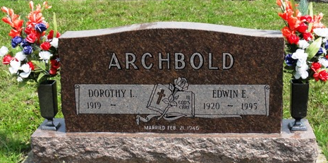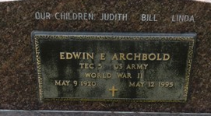
Photo by Kay Bradtmiller

Edwin E. Archbold, 75, of Ossian died yesterday in Ossian. The former 40-year Uniondale resident had retired from American Hoist in 1985 after 12 years of service and had worked at Phelps Dodge for 18 years. He was a World War II Army veteran.
Surviving are his wife, Dorothy L.; daughters, Judith Archbold of Fort Wayne and Linda Kiefer of Bluffton; brothers, Dale Archbold of Fort Wayne and Duane Archbold of Angola; and four grandchildren.
Services are 1:30 p.m. Monday at Elzey & Haggard Funeral Home in Ossian, where calling is from 2 to 4 and 7 to 9 p.m. tomorrow. Burial will be in Oaklawn Cemetery, Ossian.
Preferred memorials are gifts to VFW Post 2861, Ossian or St. Mark's Church in Uniondale.

News-Sentinel, Allen County, Indiana
Saturday, May 13, 1995

