Edna Louise (Jones) Archbold
June 1, 1928 – February 28, 1999

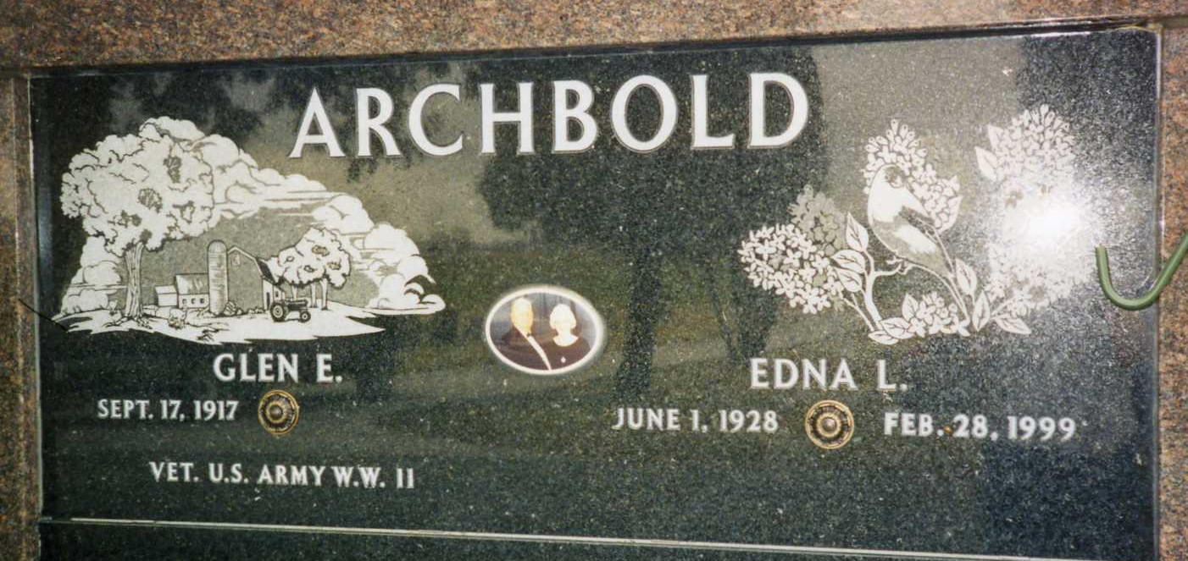
Photo by drbuck

Edna L. Archbold, 70, of Ossian, a member of Ossian Nazarene Church, died Sunday, Feb. 28, 1999, at Lutheran Hospital. "She was a loving wife, mother and grandmother."
The Mount Summit native was a hair dresser in her own home, had worked for J.C. Penney from 1971-1975, for General Electric in Fort Wayne and was a member of Fort Wayne American Legion Auxiliary Post 296.
Surviving are her husband, Glen E.; daughters Cindi Archbold-Runser of Ossian and Lisa Irmscher of Fort Wayne; a brother, Harry Jones of Wilkinson; and three grandchildren. She was preceded in death by a brother, Johnny Jones.
Services are 2 p.m. Thursday at Elzey & Haggard Funeral Home, Ossian, with calling from 2 to 5 and 7 to 9 p.m. Wednesday. Burial will be in Oak Lawn Cemetery, Ossian. Memorials are to the church.

News-Sentinel, Allen County, Indiana
Tuesday, March 2, 1999

