Edna G. (Woods)Archbold
July 20, 1896 – July 22, 1984

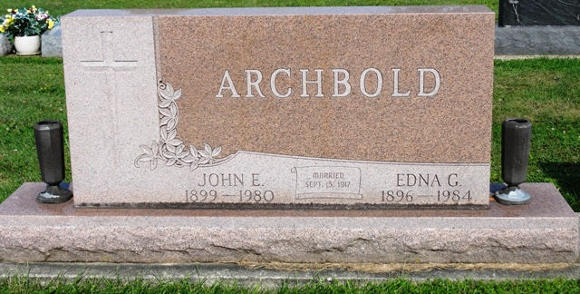
Photo by HoosierGirl88

Indiana, U.S., Death Certificates, 1899-2017
Name Edna G. Archbold
[Edna G. Woods]
Gender Female
Race White
Marital Status Widowed
Age 88
Birth Date 20 Jul 1896
Birth Place Indiana
Death Date 22 Jul 1984
Death Place Bluffton, Wells, Indiana, USA
Death Registration Date 1984
Father Frank Woods
Mother Edith Wilcoxin
Informant Harold Archbold, son
Burial Oak Lawn 7/25/1984

