Eleanor Grace (Deam) Archbold
November 9, 1872 – October 1, 1959

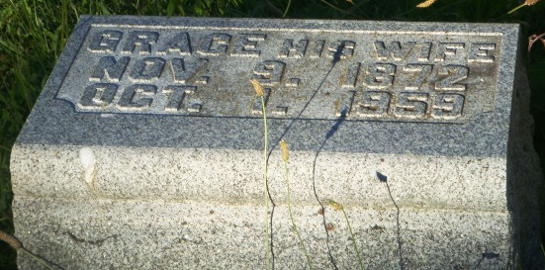
Photo by HoosierGirl88

Indiana, U.S., Death Certificates, 1899-2017
Name Eleanor Grace Archbold
[Eleanor Grace Deam]
Gender Female
Race White
Marital Status Widowed
Age 86
Birth Date 9 Nov 1872
Birth Place Indiana
Death Date 1 Oct 1959
Death Place Huntington Co., Huntington, Indiana, USA
Death Registration Date 1959
Father John Deam
Mother unknown
Informant Lawrence G. Archbold, son
Burial 10/3/1959 Ossian Cemetery

