Dorothy L. (Miller) Archbold
April 21, 1919 – December 10, 2020

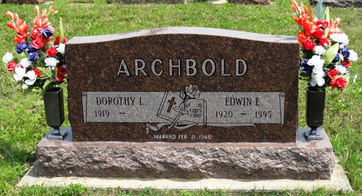
Photo by HoosierGirl88

Dorothy L. Archbold, 101 of Ossian, passed away on Thursday evening, December 10, 2020, at Christian Care Retirement Community in Bluffton. Dorothy was born on April 21, 1919 in Brownsville, Minnesota to William F. & Emma (Luehr) Miller and was a 1937 graduate of Caledonia High School. She completed Business School and learned shorthand in Lacrosse, Wisconsin. She worked at General Electric in Fort Wayne. During World War II, Dorothy traveled with her friend Lorraine by train to Seattle, Washington where she worked in the Department of Agriculture.
On February 21, 1946 in Uniondale, Dorothy and Edwin E. Archbold were married. He preceded her in death on May 12, 1995.
Dorothy was a nurturing mother and was a faithful member of St. Mark’s Lutheran Church in Uniondale. She also loved to square dance and polka. Dorothy enjoyed music and had a talent for playing the organ and piano.
Survivors include her three children; Judith D. Archbold of Fort Wayne, Linda (Don) Kiefer and William Archbold and companion Pat, both of Bluffton. She was a loving grandma to 4 grandchildren; Eric (Angela) Kiefer, Brent (Danielle) Archbold, Holly (Chad) Gentry and Kirk (Elizabeth) Kiefer and 6 great-grandchildren; Alyssa Kiefer, Kayla Kiefer, Edwin J. Archbold, Kole Kiefer, Connor Archbold and Corbin Archbold.
Dorothy is preceded in death by her parents, husband Edwin and siblings; Raymond Miller, William Miller, Norma Bolinger and Florence Kuecker.
A private family service will be held at the Thoma/Rich, Lemler Funeral Home in Bluffton with Pastor Jarrod Ball officiating.
Friends wishing to watch Dorothy’s service can do so from the safety of their home, utilizing a Zoom Meeting. Private family burial will follow at Oaklawn Cemetery in Ossian.
Memorials may be made in Dorothy’s memory to the St. Mark’s Lutheran Church or Disabled American Veterans and should be mailed to the funeral home.

Thoma/Rich, Lemler Funeral Home, Wells County, Indiana

