Curtis Clyde Archbold
June 1882 – February 3, 1920

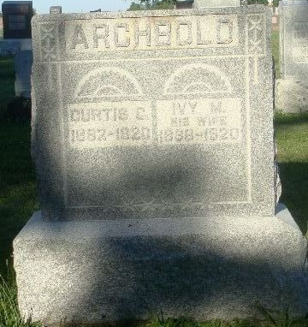
Photo by HoosierGirl88

Indiana, U.S., Death Certificates, 1899-2017
Name Custis Clyde Archbold
Gender Male
Race White
Marital Status Married
Age 37y 7m 19d
Birth Date 15 Jun 1882
Birth Place Indiana
Death Date 4 Feb 1920
Death Place Jefferson, Wells, Indiana, USA
Death Registration Date 1920
Father Emmit Archbold
Mother Louisa Caid
Spouse Ivah Archbold
Informant Mrs. Emmit Archbold
Burial Ossian, Ind. 2/7/1920

