Christine M. (Mackey) Archbold
February 1, 1880 – July 7, 1958

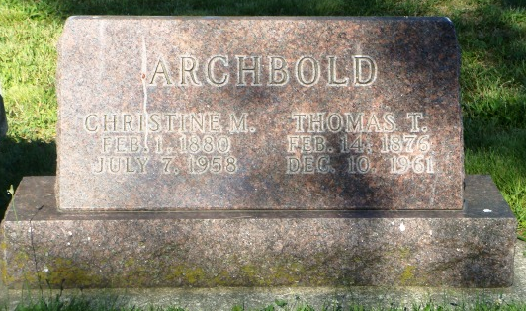
Photo by HoosierGirl88

Indiana, U.S., Death Certificates, 1899-2017
Name Christine Archbold
[Christine Mackey]
Gender Female
Race White
Marital Status Married
Age 80
Birth Date abt 1878
Birth Place Indiana
Death Date 7 Jul 1958
Death Place Ossian, Wells, Indiana, USA
Father John Mackey
Mother Christine Nickel
Spouse Thomas T Archbold, informant
Burial 7/9/1958 Oak Lawn

**
Indiana, Marriages, 1810-2001

Name Christena Mackey
Gender Female
Race White
Age 26
Birth Date 1 Feb 1880; Birth Place Adams
Marriage Date 27 Dec 1906; Marriage Place Indiana, United States
Residence Place Wells
Father John Mackey
Mother Christena Nickle
Spouse Tom Archibold
Page 259
FHL Film Number 002318673

