David A. “Birt” Archbold
March 3, 1873 – May 10, 1914

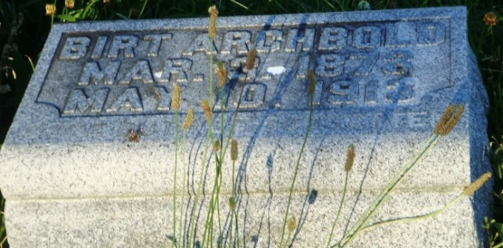
Photo by HoosierGirl88

Indiana, U.S., WPA Death Index, 1882-1920
Name David A. Archbold
Date May 10, 1913
Location Wells County
Age 40 Yr
Gender Male
Race White
Source location County Health Office, Bluffton
Source notes The source of this record is the book H-5 on page 55 within the series produced by the Indiana Works Progress Administration.
**
Indiana, U.S., Marriage Certificates, 1960-2012
Name David A Archbold
Gender Male
Marriage License Date 24 Sep 1896
Marriage Date 24 Sep 1896
Marriage Place Wells, Indiana, USA
Spouse Elnora G Deam
Officiator James H Hawk

