Amanda Jane (Stubbs) Archbold
December 30, 1868 – November 13, 1908

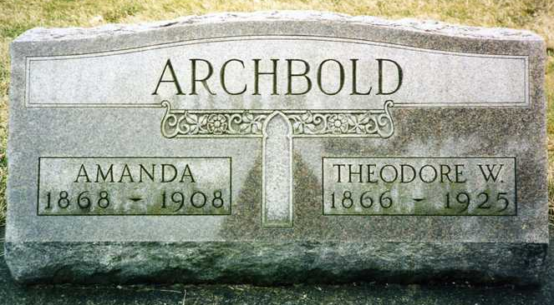
Photo by drbuck

Amanda Jane Stubbs from tree STOKLEY Family Tree
Birth 30 Dec 1868 Marion, Marion, Ohio, USA
Marriage 23 Nov 1893 Wells, Indiana, USA
Residence 1900 Wells, Indiana, USA
Death 13 Nov 1908 Ossian, Wells, Indiana, USA
Father Thomas C Stubbs (1848-1916)
Mother Jane Walker (1838-1911)
Spouse Theodore Wilson Archbold (1866-1925)
834 People 9 Records 16 Sources

