Ruthell E. (Woodward) Andrews
May 3, 1913 – May 21, 2007

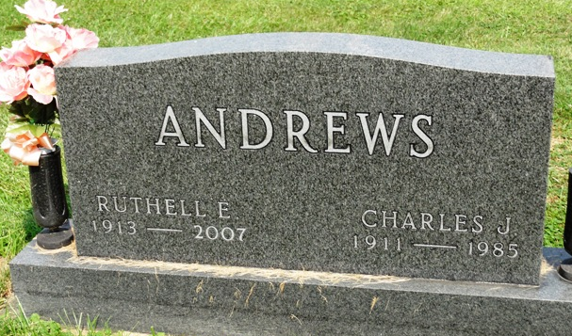
Photo by HoosierGirl88

RUTHELL E. ANDREWS, 94, of Ossian, died Monday, May 21, 2007, at Ossian health Care & Rehabilitation. Born May 3, 1913, in Wells County, she was a cook at Ossian High School and member of Ossian First Presbyterian Church. She married Charles J. Andrews on June 3, 1933; he died on April 28, 1985.
Surviving are one son, Ross (Jeanie) Andrews of Burnettsville; one daughter, Carolyn (Charles) Dennis of Ossian; one sister, Mary Lou Peck of Chicago, Ill.; five grandchildren; nine great-grandchildren; and two great-great-grandchildren. She was also preceded in death by her parents, Ellis M. and Hazel I. Mahnensmith Woodward.
Funeral service is 2 p.m. Saturday at Elzey-Patterson-Rodak Funeral Home, 120 W. Mill St., Ossian, with visitation two hours prior. Burial in Oak Lawn Cemetery, Ossian. Memorials to First Presbyterian Church, Ossian.

Fort Wayne newspapers, Allen County, Indiana
May 23, 2007

